**DEVICE MANAGER APP**

**FINAL SUBMISSION**

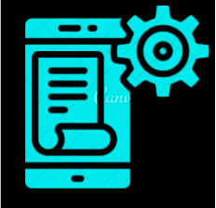

GROUP 30:

Harshal (2020062)

Rahul Jaiswal(2020109)

Mohammad Atif Quamar (2020523)

Abhishek (2020014)

Vishesh Rangwani (2020155)

**PROBLEM STATEMENT**:

Everyone uses so many IoT devices. People have difficulty to manage all of them. They face issues such as keeping track of battery left on the device. People also forget where they had kept their rarely used devices and have to spend lot of effort and time searching them.

**SOLUTION STATEMENT**:

This app helps user to manage all their IoT devices. Users can keep remote track of battery of all their devices status and various options related to it such as setting reminder and scheduling your events for app to suggest appropriate charging time. App also lets you track all devices from one place.

**FIGMA LINK:**

[**https://www.figma.com/proto/gmasFwj1ycbSkXLS5L7fTM/Untitled?node-id=120%3A26&scaling=scale-down&page-id=120%3A5**](https://www.figma.com/proto/gmasFwj1ycbSkXLS5L7fTM/Untitled?node-id=120%3A26&scaling=scale-down&page-id=120%3A5)

**DESIGNER’S NOTES FORMS:**

<https://docs.google.com/forms/d/195EWr00EEW8EoP5q-XStEdp6wO7m7Pnofx90IFPJalM/edit?usp=sharing>

**COMMON FUNCTIONALITIES ON EACH SCREEN:**

1. i button was added on some screens. Hovering over the button displays a pop up description of that option.
2. Back button is present on each screen to undo an operation.
3. User can access some general options from the hamburger menu available on each screen.

SCREEN 1: Landing page of the app.

Dual tone colour could have been used at the heading label

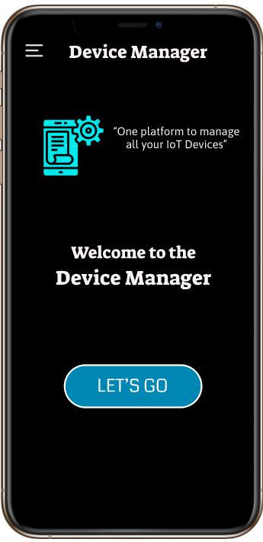

The change can be incorporated by using dark gray labels

Clickable Hamburger menu (available on all screens)

STEP 1:

Click this button to get started with the app.

DESCRIPTION:

This is the first screen of our app. It provides a welcome note to the user and button to enter into the app.

SCREEN 2: Select the desired user

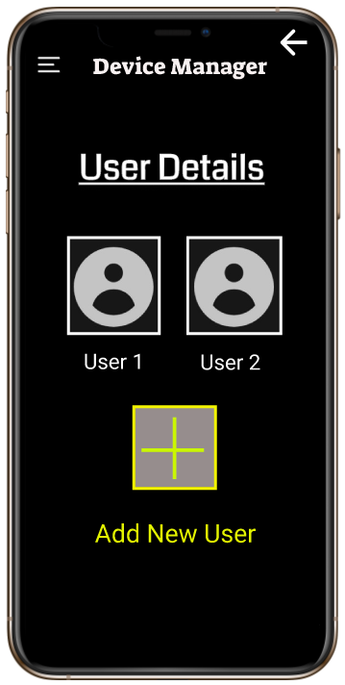

A delete user icon can be added

There is no option for removing a user.

The ‘back’. Button can be positioned in bottom left of screen

The ‘back’ button’s position is not obvious. It should have been in top left or bottom left.

STEP 2:

Click this button to get a list of various options the ‘User 1’ can perform.

DESCRIPTION:

Select the desired user from the list of options provided. The screen also displays an option to add a new user.

SCREEN 3: Screen displays the available functions

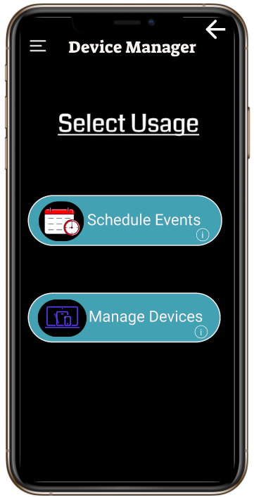

STEP 3:

Select this option to get a list of your devices which you can manage.

DESCRIPTION:

This screen allows the user to select an option between scheduling/planning his events and remotely managing all his IoT devices

SCREEN 4: Displays various devices which the user has added

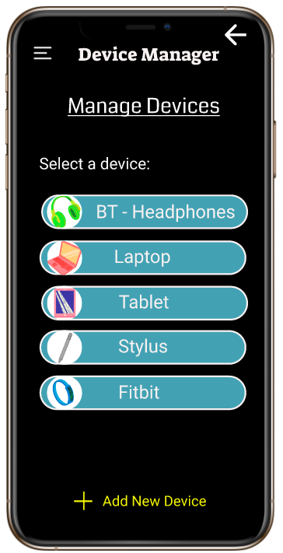

A delete device button can be added. (Solution based on problem on screen 2)

The option could be boxed in a well coloured box

Plane text, not perceived as a button and could be ignored due to positioning at bottom.

STEP 4:

Select this option to get information about ‘fitbit’.

DESCRIPTION:

The screen displays various devices of the user and also gives an option to add a new device. The user can select the desired device whose information he wants to access.

SCREEN 5: Displays the options which you can perform

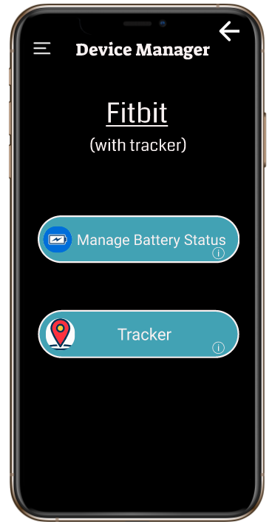

The font size of all ‘i’ button pop up text box could have been made larger

Font size of the ‘i’ button pop up was too small.

STEP 5:

Select this option to get options to see the details about the battery status

DESCRIPTION:

The screen displays the options to either track your device or go to a page to see the various options to manage battery.

SCREEN 6: Displays various options to manage your device’s battery

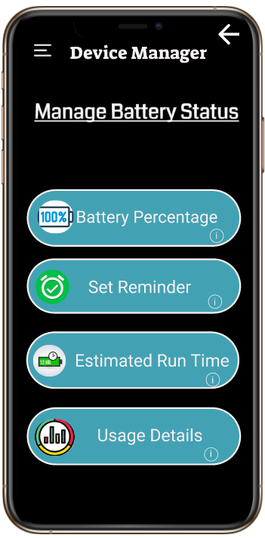

STEP 8:

Select this button to go to the respective screen and then click back from there to select fourth option

STEP 9:

Click on this button to go to the last screen

STEP 6:

Select this button to go to the respective screen and then click back from there to select second option

STEP 7:

Select this button to go to the respective screen and then click back from there to select third option

Leads to screen 6.1

Leads to screen 6.2

Leads to screen 6.3

Leads to screen 6.4

DESCRIPTION:

This screen displays the various functionalities which the app can perform to manage the selected device’s battery status.

All the four options are clickable and you can select any of these.

SCREEN 6.1: Pictorial depiction of current battery percentage

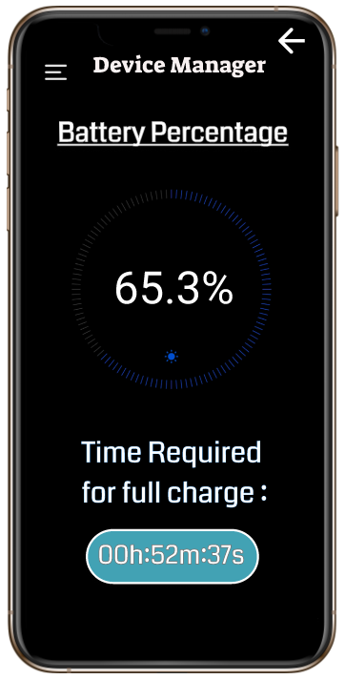

A brighter colour which is easily distinguished can be used.

The pictorial representation’s colour was not distinctly visible

Click on back and select the second option

DESCRIPTION:

This screen displays the current battery percentage and the time required for full charge.

SCREEN 6.2: Options to set reminder to charge battery.

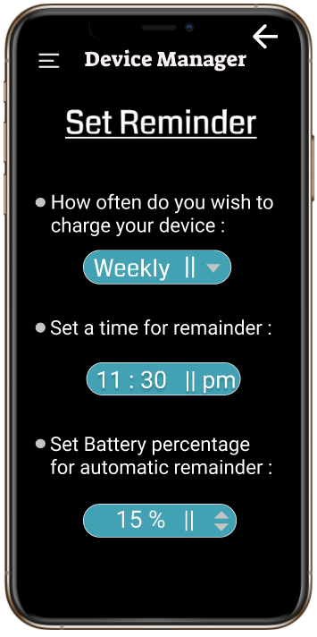

STEP 7.2:

You can vary this between 15% to 20%

STEP 7.1:

Select an option from the drop down menu

Click on back and select the third option

DESCRIPTION:

This screen displays various options to set reminders based on different conditions which can be specified.

SCREEN 6.3: Screen to show estimated run time

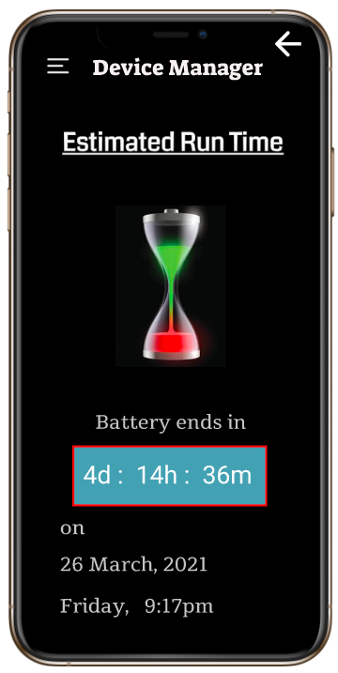

Click on back and select the fourth option

DESCRIPTION:

This screen tells the time till which the battery in the device would last. It also mentions predicted date and time when it will be discharged.

SCREEN 6.4: Battery Usage Stats

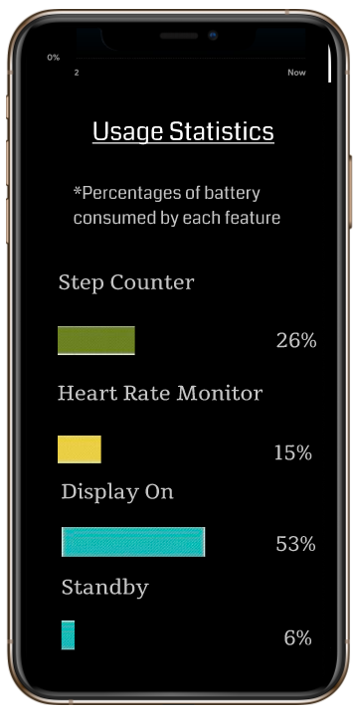

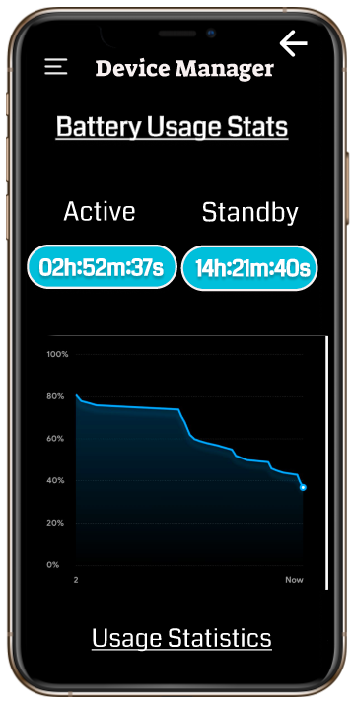

Scrollable Screen

DESCRIPTION:

This screen displays a graphical representation of the battery usage statistics, active and standby time of the selected device.

It also gives the statistics of the percentage of battery consumed by each feature of the ‘fitbit’ device.

SCREEN: Hamburger Menu

Clicking this button takes you to the First Screen of the app.

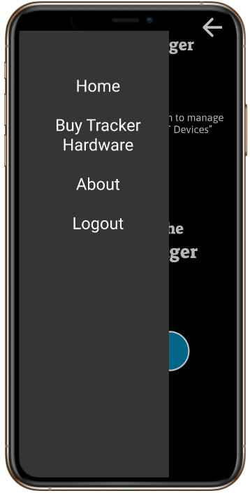

The option could have been made descriptive. The option is ambiguous since all the screens of the app are not made yet

This option was not self-explanatory in context of how app is presented

Clicking this button takes you to the where you can select a different users.

DESCRIPTION:

This screen displays the hamburger menu. There are various options in the menu.

If you click any of the options by mistake, there is a back button on each screen to undo what you did.